**SKIN DISEASE DETECTION USING IMAGE PROCESSING WITH SVM**

**A PROJECT REPORT**

***Submitted by***

**SRICHARAN P**

**AKASH M**

***in partial fulfillment for the award of the degree***

***of***

**BACHELOR OF ENGINEERING**

**IN**

COMPUTER SCIENCE AND ENGINEERING



**SRI SAIRAM ENGINEERING COLLEGE, CHENNAI**

**ANNA UNIVERSITY: CHENNAI 600 025**

MARCH 2020

**ANNA UNIVERSITY: CHENNAI 600 025**

**BONAFIDE CERTIFICATE**

Certified that this project report **“SKIN DISESASE DETECTION USING IMAGE PRCESSING WITH SVM”** is the bonafide work of **“SRICHARAN P (412516104140)** and **AKASH M (412516104017)”** who carried out the project work under my supervision.

**SIGNATURE SIGNATURE**

Dr. B. Latha, M.E, Ph.D., Mr. M.BALAMURUGAN, M.Tech,

**HEAD OF DEPARTMENT,** **SUPERVISOR,**

Department of Computer Department of Computer

Science and Engineering Science and Engineering

Sri Sai Ram Engineering College Sri Sai Ram Engineering College

West Tambaram West Tambaram

Chennai-600 044 Chennai-600 044

Submitted for the Anna University Examination held on ____________.

**(EXAMINER1) (EXAMINER2) (EXAMINER3)**

**ACKNOWLEDGEMENT**

We express our gratitude to our respected Chairman (Late) **Mr**.**MJF.Ln.Leo Muthu** and CEO **Mr. J. SAI PRAKASH** for his constant encouragement in completion of this project.

We extend solemn thanks to our Principal **Dr. A. RAJENDRA PRASAD** for having given us his whole-hearted encouragement for completion of this project.

We are indebted to our Head of the Department **Dr. B. LATHA** for her support during the entire course of this project.

Our special thanks to our Project Coordinator **Mr. M. BALAMURUGAN**, Assistant Professor, for his kind support in bringing out this project successfully.

Our sincere thanks to our Supervisor, **Mr. M. BALAMURUGAN**, Assistant Professor, for helping us in successful completion of this project.

Finally, we would like to thank all the staff members of the Department of Computer Science and Engineering, our parents, friends and all others who contributed directly and indirectly for the successful completion of our project

# ABSTRACT

Skin diseases are hazardous and often contagious, especially melanoma, eczema, and impetigo. These skin diseases can be cured if detected early. The fundamental problem with it is, only an expert dermatologist is able to detect and classify such disease. Sometimes, the doctors also fail to correctly classify the disease and hence provide inappropriate medications to the patient. Our system proposes a skin disease detection method based on Image Processing and Machine Learning Techniques. The patient needs to provide the image of the infected area and it is given as an input to the application. Initially, images were preprocessed to remove noise and irrelevant background by filtering and transformation. The method of grey-level co-occurrence matrix (GLCM) was introduced to segment images of disease. Texture and color features of different disease images could be obtained accurately.

**TABLE OF CONTENTS**

**CHAPTER NO TITLE PAGE NO**

**ABSTRACT iv**

**LIST OF FIGURES ix**

**LIST OF ABBREVIATIONS x**

**LIST OF TABLES x**

**1 INTRODUCTION 1**

* 1. PROJECT OVERVIEW 1
  2. OBJECTIVE 2
  3. DOMAIN OVERVIEW 2

1. **LITERATURE SURVEY 4**

2.1 LITERATURE SURVEY 1 4

2.1.1 ADVANTAGES 4

2.1.2 DISADVANTAGES 4

2.2 LITERATURE SURVEY 2 5

2.2.1 ADVANTAGES 5

2.2.2 DISADVANTAGES 5

2.3 LITERATURE SURVEY 3 6

2.3.1 ADVANTAGES 6

2.3.2 DISADVANTAGES 6

2.4 LITERATURE SURVEY 4 6

2.4.1 ADVANTAGES 7

2.4.2 DISADVANTAGES 7

2.5 LITERATURE SURVEY 5 7

2.5.1 ADVANTAGES 8

2.5.2 DISADVANTAGES 8

2.6 LITERATURE SURVEY 6 8

2.6.1 ADVANTAGES 9

2.6.2 DISADVANTAGES 9

2.7 LITERATURE SURVEY 7 9

2.7.1 ADVANTAGES 10

2.7.2 DISADVANTAGES 10

2.8 LITERATURE SURVEY 8 11

2.8.1 ADVANTAGES 11

2.8.2 DISADVANTAGES 11

2.9 LITERATURE SURVEY 9 12

2.9.1 ADVANTAGES 12

2.9.2 DISADVANTAGES 12

**3 SYSTEM ANALYSIS 13**

3.1 EXISTING SYSTEM 13

3.1.1 CONSTRAINTS 14

3.2 PROPOSED SYSTEM 14

3.2.1 ADVANTAGES 15

**4 REQUIREMENT SPECIFICATION 16**

4.1 HARDWARE AND SOFTWARE

REQUIREMENTS 16

4.1.1 HARDWARE REQUIREMENTS 16

4.1.2 SOFTWARE REQUIREMENTS 16

4.2 SOFTWARE DESCRIPTION 16

4.2.1 MATLAB 2019a 16

4.2.2 IMAGE PROCESSING TOOLBOX 18

4.3 TECHNOLOGIES USED 20

4.3.1 SVM ALGORITHM 20

4.3.2 GLCM ALGORITHM 21

|  |  |  |
| --- | --- | --- |
| **5** | **SYSTEM DESIGN** | **26** |
|  | 5.1 ARCHITECTURE DIAGRAM | 26 |
|  | 5.2 UMLDIAGRAMS | 28 |
|  | 5.2.1 USECASE DIAGRAM | 29 |
|  | 5.2.2 CLASS DIAGRAM | 30 |
|  | 5.2.3 SEQUENTIAL DIAGRAM | 31 |
|  | 5.2.4 ACTIVITY DIAGRAM | 32 |
|  | 5.2.5 COLLABORATION DIAGRAM | 34 |
|  |  |  |
| **6** | **SYSTEM IMPLEMENTATION** | **35** |
|  | 6.1 MODULE DESCRIPTION | 35 |
|  | 6.1.1 TRAIN DATABASE | 36 |
|  | 6.1.2 PRE-PROCESSING | 36 |

6.1.3 SEGMENTATION 36

6.1.4 CLASSIFICATION 37

1. **SYSTEM FEATURES 38**

7.1 SYSTEM FEATURE 1 38

7.2 SYSTEM FEATURE 2 39

1. **NON-FUNCTIONAL REQUIREMENT 40** 
   1. PERFORMNACE 40
   2. SAFETY 40
   3. SECURITY 41

8.4 SOFTWARE QUALITY 41

8.4.1 RELIABILTY 41

8.4.2 USABILITY 41

8.4.3 PORTABILITY 41

8.4.4 MAINTAINABILTY 41

**9 CONCLUSION 42**

**APPENDIX 1: SCREENSHOTS 43**

**APPENDIX 2: SAMPLE CODING 46**

**REFRENCES 51**

**LIST OF FIGURES**

|  |  |  |  |  |  |
| --- | --- | --- | --- | --- | --- |
|  |  |  | |  | |
| **FIGURE NO.** |  | **TITLE** | | **PAGE NO.** | |
| 5.1.1 |  | ARCHITECTURE DIAGRAM |  |  | 27 |
| 5.2.1.1 |  | USE CASE DIAGRAM |  |  | 29 |
| 5.2.2.1 |  | CLASS DIAGRAM |  |  | 30 |
| 5.2.3.1 |  | SEQUENCE DIAGRAM |  |  | 31 |
| 5.2.4.1 |  | ACTIVITY DIAGRAM |  |  | 33 |
| 5.2.5.1 |  | COLLABORATION DIAGRAM |  |  | 34 |
| 6.1.1 |  | MODULES REPRESENTATION |  |  | 35 |
| A.1.1 |  | TRAIN DATABASE |  |  | 43 |
| A.1.2 |  | PRE-PROCESSING | |  | 44 |
| A.1.3 |  | SEGMENTATION | |  | 44 |
| A.1.4 |  | CLASSIFICATION | |  | 45 |
|  |  |  | |  |  |
|  |  |  | |  |  |
|  |  |  | |  |  |
|  |  |  | |  |  |

**LIST OF ABBREVIATIONS**

**S. NO ABBREVATION EXPANSION**

1. SVM SUPPORT VECTOR MACHINE
2. GLCM GRAY LEVEL CO-OCCURRENCE MATRIX

**LIST OF TABLES**

**SNO TITLE PAGE NO**

1 PERFORMANCE ANALYSIS 40

**CHAPTER 1**

**INTRODUCTION**

The skin is the largest organ in the human body and has numerous potential abnormalities; there are about 1500 distinct skin diseases. We are relatively ignorant about the symptoms of the majority of these diseases although knowledge is rapidly increasing, however, that makes it a challenge for dermatologist to diagnose them.

Nowadays technologies have changed our day-to-day life in all aspects and the medical field is not an exception, many medical systems have been developed to help both patients and doctors in different ways, starting from registration process ending with the use of technologies for diagnosing diseases.

This chapter gives an overview about the problem statement of the project, the objectives to be achieved, motivation of the project and brief view about the methods used in the implementation. In addition, an overview of report layout will be presented.

## PROJECT REVIEW:

Skin diseases rate has been increasing for past few decades, many of these diseases are very dangerous, particularly if not treated at early stages. In Sudan skin diseases are big issue, according to the latest WHO data published in May 2014 Skin Diseases Death in Sudan reached 1,974 or 0.76% of total death. The age adjusted death rate is 9.81 per 100,000 of population, this result ranks Sudan number 8 in the world.

In addition, dermatologist use variety of visual clues such as color, scaling and arrangement of lesions, the body site distribution and others, when these individual components are analyzed separately, the recognition of the disease can be quite complex that requiring high level of experience. Diagnosis by humans depends on subjective judgment of the dermatologists so it’s hardly reproducible, unlike computer aided diagnostic systems which are more realistic and reliable.

Since most of the Sudanese have dark skin then most of the applications that have been developed in this region are not properly applicable locally in Sudan.

## OBJECTIVES

The objective of this project can be summarized into the following points:

1. Develop Deep learning application that in general, has the ability to:
   * Determine the affected areas in the image.
   * Determine the disease in the specified region.
   * Be applicable locally in India.
2. Develop a Android Tablet interface that:
   * Capture the image; send it to the server and receiving the results back.

## DOMAIN OVERVIEW:

Machine Learning (ML) is a branch of artificial intelligence, a science that researches machines to acquire new knowledge and new skills and to identify existing knowledge. ML is one of the most exciting technologies that one would have ever come across. As it is evident from the name, it gives the computer that which makes it more similar to humans: “The ability to learn”. Machine learning is actively being used today, perhaps in many more places than one would expect. Deep learning (also known as deep structured learning or hierarchical learning) is part of a broader family of machine learning methods based on learning data representations, as opposed to task-specific algorithms. Deep learning models are vaguely inspired by information processing and communication patterns in biological nervous systems. The neural networks are always better than decision trees, and vice versa. There are many factors at concern, such as the size and structure of the data set. Therefore, it is better to experiment with a variety of different algorithms for specific problems and set aside a data “test set” to evaluate performance for precise results. Thus, our project uses K means algorithm with Naïve bayes classification and KNN.

**CHAPTER 2**

**LITERATURE SURVEY**

**2.1 Computer aided method to detect Melanoma skin cancer using image processing** - Sanjay Jaiswar, Mehran Kadri and Vaishali Gatty – 2014

In the year 2014 there was many attempts for developing better Skin Diseases Diagnosis systems, the image samples were provided to the system, many preprocessing techniques are applied, these techniques were image illumination equalization, color range normalization, image scale fitting and image resolution normalization, then images are passed through a segmentation phase. There were 3 algorithms used for segmentation, threshold based segmentation, clustering techniques and edge detection based, then features -Asymmetry index, Border Irregularity, Color index and Diameter- were extracted from the images to be used as basis for the detection, then TDS index is calculated from the extracted features to determine the existence of a cancer disease or not according to the value of the TDS index, the output given by this system will help the dermatologist to detect the lesion and its type, but it can’t be implemented as standalone equipment for the diagnosis process.

**2.1.1 ADVANTAGES:**

* Melanoma dermoscopic characteristics are well correlated to histopathologic features
* Useful in the follow-up management and easy comparison for detecting change in size, shape, or color that may be suggestive of malignancy.

**2.1.2 DISADVANTAGES:**

According to the value of the TDS index, the output given by this system will help the dermatologist to detect the lesion and its type, but it can’t be implemented as standalone equipment for the diagnosis process.

**2.2 A System that suggest a diagnosis regarding skin diseases from erythemato-scuamous class** - Delia-Maria FILIMON and Adriana ALBU – 2014

In the year 2014 , the system was developed in Matlab environment, its neural network has a hidden layer with 10 neurons, output layer with 6 neurons which has been trained using backpropagation learning algorithm, the system also has 33 inputs of clinical and histopathological feature of the patients, based on these features and the predicted disease the system provides suggestions of the medical treatments of the patient. Although this system got an accuracy that is almost 94% but it doesn’t use features that are extracted from an image of the infected area of the skin, it completely depends on clinical features; it also used to diagnose uncommon diseases with a threshold output.

**2.2.1 ADVANTAGES:**

* This system got an accuracy that is almost 94%
* It also used to diagnose uncommon diseases with a threshold output.
  + 1. **DISADVANTAGES:**
* It doesn’t use features that are extracted from an image of the infected area of the skin, it completely depends on clinical features

**2.3 A computer aided diagnosis system for Skin Cancer** - Sarika Choudhari and Seema Biday – 2014

In the year 2014, based on dermascopy images of the skin that were enhanced by applying many preprocessing techniques, Dull Razor Filter to remove hair, obtaining the grayscale of the image, contrast enhancement and median filter to remove noise, the infected area was segmented from the rest of the skin according to its binarized gray level by applying Maximum Entropy. Thresholding, Level Co-occurrence Matrix (GLCM) was implemented to extract features from the enhanced image, multi- layers Feedforward Artificial Neural Network with backpropagation learning algorithm was used as a classifier that trained based on the extracted features, their Methodology has got 86.66% as accuracy, but this system only detects whether it’s a Melanoma or non- melanoma so it couldn’t differentiate between different types of skin diseases despite of their seriousness.

**2.3.1 ADVANTAGES:**

* This system got an accuracy that is almost 86.66%.
  + 1. **DISADVANTAGES:**
* This system only detects whether it’s a Melanoma or non- melanoma so it couldn’t differentiate between different types of skin diseases despite of their seriousness.

**2.4 A computer vision based techniques to detect different diseases from color images** - Rahat Yasir, Md. Ashiqur Rahman, and Nova Ahmed – 2014

In the year 2014,The system successfully detects 9 different types of dermatological skin diseases with an accuracy rate of 90% , they have used 10 feature, 7 features were extracted from user’s input (liquid type, liquid color, elevation, duration, feeling, gender, age) and 3 features were extracted from the image(color, area, edge), those features were extracted using eight different types of algorithms which are grey image, sharpening filter, median filter, smooth filter, binary mask, histogram, YCbCr and sobel operator. They have trained these 10 features as input to train and test into a feed forward back propagation artificial neural network to identify the dermatological disease. Although this model has high accuracy but it depends on only 10 features only 3 of them are extracted from the image, and the rest are taken as input from the user, which might not be accurate enough (take feeling as example). making it more human dependent and less automated. In 2015 they have implemented the same model above that have android interface to the system functions, making it portable and more friendly in use.

**2.4.1 ADVANTAGES:**

* Although this model has high accuracy

**2.4.2 DISADVANTAGES:**

* It depends on only 10 features only 3 of them are extracted from the image, and the rest are taken as input from the user

**2.5 An Image analysis system to detects skin diseases** - Pravin S. Ambad1, A. S. Shirsat – 2016

In the year 2016, they develop a system to be used for early detection and prevention of the skin diseases and they target 3 main diseases skin cancer, psoriasis and dermatophilosis, the disease diagnosis and classification is built on statistical parameter analysis. Statistical parameters include: Entropy, Texture index, Standard deviation, Correlation, the user of the system will able to take images of different moles or skin patches. Then the system will analyze and process the image and classifies the image to normal, melanoma, psoriasis or dermo case based extracting the image features.an alert will be provided to the user to seek medical help if the mole belongs to the atypical or melanoma category, the input images firstly passed through a median filter to remove a remove the noise, then apply the image enhancement and the statistical analysis techniques, then two-level classifier is used the first level is to specify if the image is either normal or abnormal and the second level is to classify into specified category: Melanoma, Psoriasis or dermo, the system is classify the images with accuracy 90%.

**2.5.1 ADVANTAGES:**

* Melanoma, Psoriasis or dermo, the system is classifying the images with accuracy 90%.

**2.5.2 DISADVANTAGES:**

* The system can only recognize 3 diseases(Eczema, Impetigo and Melanoma), also the distance between camera lens and affected skin was 5cm in addition it only developed for windows operating system.

**2.6 Detect 6 different skin diseases using Android Tablet-**Vinayshekhar Bannihatti Kumar, Sujay S Kumar and Varun Saboo – 2016

In the year 2016, They have implemented dual stage approach combines machine learning and computer vision [18]. The computer vision consists of two stages in the first stage eight preprocessing techniques were implemented in order to extract features of the image namely converting to grey scale image, sharpening filter, median filter, smooth filter, binary mask, RGB extraction, histogram and sobel operator, the extracted features are used as input for training two different models in the second stage, these models are Maximum Entropy model and Feed forward Artificial Neural Network with two hidden layers and Softmax output layer that learned using Backpropagation learning algorithm, this stage was developed for users that couldn’t access the histopathological attributes. In the Machine Learning stage the histopathological attributes entered by the user combined with the features have been extracted from the image were used as input to train three different training models, Decision Tree, Feedforward Neural Network, and K’th Nearest Neighbor. The novel method of using a dual stage system has given very promising results in identification of skin diseases with accuracies of up to 95%, although they got high accuracy but it decreases when tested with varying skin colors.

**2.6.1 ADVANTAGES:**

* The novel method of using a dual stage system has given very promising results in identification of skin diseases with accuracies of up to 95%,

**2.6.2 DISADVANTAGES:**

* Although they got high accuracy but it decreases when tested with varying skin colors.

**2.7 A Computer based skin disease detection system using digital image processing techniques for the classifications of the infected skin**- Suneel Kumar and Ajit Singh – 2016

In the year 2016, the unique features of the images were extracted using two algorithms HSV-histogram and SURF algorithm, then the extracted features were fed in a K-NN classifier to classify the image to normal skin or infected, 5 classes were used in which 5 shows the normal skin and 1 to 4 is showing the infected skin (i.e. 1 for bloody, 2 for burned, 3 for cancer and 4 for allergic skin), this model got good accuracy, but it only classify the images into a general classification level and do not has a further detailed disease classes, but it could be very useful in medical field to see the clear image of the infected part in the skin as well as the parts that are not visible by human eyes. the dataset used in the model is from two main sources, Dermnet dataset which include 23,000 skin disease images and more than 600 skin diseases divided into 23 main classes of diseases and OLE dataset which contains more than 1300 skin disease images and 19 skin diseases, the convolutional neural network is built on the Dermnet dataset and the classes taken is the main 23 classes, then the system is tested using the Dermnet dataset and the OLE dataset, the resultant accuracy of the test using the Dermnet dataset was 73.1% for the top-1 accuracy and 91% for the top-5 accuracy, and the accuracy when testing with OLE dataset was 24.8% top-1 accuracy and 61.7% top-5 accuracy, the accuracy decreased due to the lack of the broader variance in the training set, so when increasing the variance in the training set the accuracy improved to 31.1% top-1 accuracy and 69.5% top-5 accuracy.

**2.7.1 ADVANTAGES:**

* This model got good accuracy.
* It is very useful in medical field to see the clear image of the infected part in the skin as well as the parts that are not visible by human eyes.

**2.7.2 DISADVANTAGES:**

* It only classifies the images into a general classification level and do not has a further detailed disease class.

**2.8 A System that enables users to recognize only 3 Skin Disease**- A.A.L.C. Amarathunga, E.P.W.C. Ellawala, G.N. Abeysekara and C. R. J. Amalraj – 2015

In the year 2015, They have used many image processing and data mining techniques have been implemented in this system, skin images were enhanced using both median and Gaussian filters, thresholding segmentation was applied, then Morphological the enhanced image were extracted, these features along with external information from the user present the input to many classifiers (AdaBoost, BayesNet, J48, MLP, NaiveBayes), both MLP and J84 were better than the rest with accuracy more that 85%, but the system can only recognize 3 diseases(Eczema, Impetigo and Melanoma), also the distance between camera lens and affected skin was 5cm in addition it only developed for windows operating system.

**2.8.1 ADVANTAGES:**

* It can be safely used by nonspecialized medical personnel.
* It is fast and can be implemented in various ways (mobile phones, computers and digital cameras).
  + 1. **DISADVANTAGES:**
* The system can only recognize 3 diseases (Eczema, Impetigo and Melanoma).
* The distance between camera lens and affected skin was 5cm in addition it only developed for windows operating system.
  1. **Skin disease identification using image processing and machine learning techniques**- G. RAJASEKARAN1, N. AISWARYA2, R. KEERTHANA – 2019

Dermatological diseases are the most prevalent diseases worldwide. Even though being common, diagnosis is extremely difficult and requires extensive experience in the domain. In this project, we provide an approach to detect various kinds of these diseases. Computer vision and Machine learning are dual stages which we used for identify diseases accurately. Our objective of the project is to detect the type of skin disease easily with accuracy and recommend the best. First stage of the image the skin disease is subject to various kinds of pre-processing techniques followed by feature extraction. Then the second stage involves it uses the Machine learning algorithms to identify diseases based on the analyzing and observance of the skin. The proposed system is highly beneficial in rural areas where access to dermatologists is limited. For this proposed system, we use PyCharm based python script for experimental results

**2.9.1 ADVANTAGES:**

* The proposed system is able to successfully detect the dermatological disease present in the image.
* The system can be deployed free of cost and the application developed is light-weight and can be used in machines with low system specifications.
  + 1. **DISADVANTAGES:**
* The system has minimal accuracy.

**CHAPTER 3**

**SYSTEM ANALYSIS**

**3.1 EXISTING SYSTEM**

Utilized computer aided diagnosis for the purpose of segmentation of the skin lesions of images obtained from dermoscopy. The methodology utilized for this was thresholding it automatically, using K- means, shifting by mean, growth regionally and Gradient Vector Flow (GVF). Composed of epidermis, dermis, and subcutaneous tissues, skin is the largest organ of human body, containing blood vessels, lymphatic vessels, nerves, and muscles, which can perspire, perceive the external temperature, and protect the body. Covering the entire body, the skin can protect multiple tissues and organs in the body from external invasions including artificial skin damage, chemical damage, adventitious viruses, and individuals’ immune system. Besides, skin can also avoid the loss of lipids together with water within epidermis and dermis so that skin barrier function can be stabilized. In spite of defences and barrier function, skin is not indestructible in that skin tends to be constantly influenced by a variety of external and genetic factors. Currently, there are three main types of skin diseases appearing in human body, including viral skin diseases, fungal skin diseases, and allergic skin disease. Despite the fact that these types of skin diseases can be cured at present, these diseases indeed have brought trouble to patients’ life. Nowadays, the majority of conclusions on the patients’ existing symptoms are drawn mainly based on doctors’ years of experience or their own subjective judgments, which may lead to misjudgments and consequently delay the treatment of these. Therefore, it is of great theoretical significance and practical value to study how to extract symptoms of diverse skin diseases on the basis of modern science and technology. Under this circumstance, effective and accurate identification of the types of skin diseases can be achieved to prescribe treatment according to patients’ symptoms. Over the past few years, the image processing technique has achieved rapid development in medicine. Some equipment based on digital image technology has also been widely applied to people’s everyday life, for instance, computed tomography (CT), digital subtraction angiography (DSA), and magnetic resonance imaging (MRI). Deeper research on this direction has been carried out by scholars all over the world. The final empirical results demonstrated that skin diseases could be accurately identified through this algorithm.

**3.1.1 CONSTRAINTS:**

Nevertheless, the paper concentrating on herpes, dermatitis, and psoriasis does not consider the different symptoms caused by the same kind of skin disease. For instance, eczema, herpes, and rubella all belong to the same series. Therefore, it will be the focus of next step to recognize different types of skin diseases of the same kind of series by using image processing technique.

**3.2 PROPOSED SYSTEM**

This chapter presents each step of the design and implementation of the skin diseases diagnosis system and discuss the methods used in each step, and provide figures and tables from the implementation process for more explanation, the chapter is divided into three main parts the first one is discussing how the data has been gathered, the second one is discussing the classification model design and implementation and the third part is considering the system development and integration.

* First step: Training database- Training of our system, several images for each of our diseases were collected. Most of the images were downloaded from several websites and the database has been trained effectively.
* Second step: Pre-Processing- Before using the images to train our model, series of reprocessing have been applied to our data to enhance the images also to increase our data for better generalization. All these processes were implemented using MATLAB image processing toolbox. This task is to load a pre-trained model and use it to classify the input data into a suitable class of skin diseases, this function is the main function of the application.
* Third step: Segmentation- Image segmentation is performed to separate suspicious lesion from normal skin. This is implemented through MATLAB.
* Fourth step: Classification-This task is to load a pre-trained model and use it to classify the input data into a suitable class of skin diseases, this function is the main function of the application.

**3.2.1 ADVANTAGES**

* The proposed work shows the improvement in identifying the melanoma skin cancer at different stages using image processing techniques based on active contour segmentation, Local binary Pattern and SVM classifier. According to the value of the TDS index, the output given by this system will help the dermatologist to detect the lesion and its type.
* support vector machine is utilized to classify the data of three different skin diseases according to the features of the texture and the lesion area, achieving a more ideal accuracy of recognition.
* In order to improve identification and treatment, the disease area of different skin diseases can be extracted on the basis of identifying the texture features so that the area of herpes, paederus, and psoriasis can be calculated, correspondingly.

**CHAPTER 4**

**REQUIREMENT SPECIFICATION**

**4.1 HARDWARE AND SOFTWARE REQUIREMENTS**

**4.1.1 HARDWARE REQUIREMENTS**

Hard disk: 90GB and above

Processor: Pentium IV 2.4GHz and above

System type: 32bit / 64 bit

RAM: 2GB and above

OS: Windows 7/8/8.1/10

**4.1.2 SOFTWARE REQUIREMENTS**

Tool : MATLAB 2019a

Tool box: Image Processing Tool Box

**4.2 SOFTWARE DESCRIPTION**

**4.2.1 MATLAB 2019a**

MathWorks today introduced Release 2019a of MATLAB and Simulink. The release contains new products and important enhancements for artificial intelligence (AI), signal processing, and static analysis, along with new capabilities and bug fixes across all product families.

“One of the key challenges in moving AI from hype to production is that organizations are hiring AI ‘experts’ and trying to teach them engineering domain expertise. With R2019a, MathWorks enables engineers to quickly and effectively extend their AI skills, whether it’s to develop controllers and decision-making systems using reinforcement learning, training deep learning models on NVIDIA DGX and cloud platforms, or applying deep learning to 3-D data,” said David Rich, MATLAB marketing director.”

**4.2.1.1 AI**

R2019a introduces Reinforcement Learning Toolbox, further enhancing the MATLAB workflow for AI. The new toolbox facilitates a type of machine learning that trains an “agent” through repeated trial-and-error interactions with an environment to solve controls and decision-making problems. The toolbox reiterates the company’s commitment to AI, building on last fall’s R2018b introduction of Deep Learning Toolbox, which was enhanced with support for NVIDIA GPU Cloud, Amazon Web Services, and Microsoft Azure, and interoperability through support of the ONNX exchange format. Further support for AI in R2019a includes significant enhancements to Computer Vision Toolbox, Data Acquisition Toolbox, and Image Acquisition Toolbox.

**4.2.1.2 Signal Processing**

R2019a features several new signal processing and communications products to support wireless and electronics development, including:

· Mixed-Signal Blockset – a Simulink add-on providing fast model construction, rapid simulation, and deep insights into mixed-signal system design models with dedicated analysis and visualization tools

· SerDes Toolbox – a Simulink add-on that offers the SerDes Designer app for rapid design, analysis, and modeling of wired communications transmitters and receivers

· SoC Blockset – a Simulink add-on that enables simulation and exploration of FPGA, ASIC and SoC architectures, cosimulation of algorithms and hardware platforms, and performance monitoring and bottleneck detection

**4.2.1.3 Static Analysis**

R2019a also makes notable advances in the company’s Polyspace static analysis product family. This includes new products that support enterprise-scale use of these products for the design and development of safety- and business-critical software:

· Polyspace Bug Finder Access and Polyspace Code Prover Access are new Polyspace products that enable collaboration for teams with up to several hundred members. The new products provide a web browser interface to Polyspace static code analysis results and quality metrics stored in a central repository

Polyspace Bug Finder Server and Polyspace Code Prover Server are new Polyspace products that allow the static analysis engine to run on a server-class machine with build automation tools. The new products automate and integrate Polyspace into software development processes to automatically assign defects, send notifications, and upload results to Polyspace Access products.R2019a is now available. For information on all new products, enhancements, and bug fixes to the MATLAB and Simulink product families, watch the R2019a Highlights video.

**4.2.2 IMAGE PROCESSING TOOLBOX**

Image Processing Toolbox™ provides a comprehensive set of reference-standard algorithms and workflow apps for image processing, analysis, visualization, and algorithm development. You can perform image segmentation, image enhancement, noise reduction, geometric transformations, image registration, and 3D image processing. Image Processing Toolbox apps let you automate common image processing workflows. You can interactively segment image data, compare image registration techniques, and batch-pr Import images and video generated by a wide range of devices, including webcams, digital cameras, satellite and airborne sensors, medical imaging devices, microscopes, telescopes, and other scientific instruments.  Support for a number of specialized image file formats. For medical images, it supports DICOM files, including associated metadata, as well as the Analyse 7.5 and Interfile formats. Use apps to explore and discover various algorithmic approaches. With the Colour Thresholder app, you can segment an image based on various colour spaces. The Image Viewer app lets you interactively place and manipulate ROIs, including points, lines, rectangles, polygons, ellipses, and freehand shapes. Increase the signal-to-noise ratio and accentuate image features by modifying the colours or intensities of an image. Perform convolution and correlation, remove noise, adjust contrast, and remap the dynamic range. Correct blurring caused by out-of-focus optics, movement by the camera or the subject during image capture, atmospheric conditions, short exposure time, and other factors.

Explore a 3D volume by using different visualization methods to explore the structure of the data. You can map the pixel intensity of a 3D volume to opacity to highlight a specific region within the volume. Use programmatic functions and interactive apps to perform 3D segmentation. You can use thresholding, active contours, semantic segmentation and other techniques to perform segmentation of 3D Data. Identify object boundaries in an image using pre-built algorithms. These algorithms include the Sobel, Prewitt, Roberts, Canny, and Laplacian of Gaussian methods. Calculate the properties of regions in images, such as area, centroid, and orientation. Use the Image Region Analysis App to automatically count, sort, and remove regions based on properties.

Find line segments, line endpoints, and circles. Statistical functions let you analyse the characteristics of an image. Colour-space conversion accurately represents color independently from devices. Use intensity-based image registration, which automatically aligns images using relative intensity patterns. Perform multimodal 3D registration and non-rigid registration, and visually inspect results by creating composite images that highlight misalignments.

**4.3 TECHNOLOGIES USED**

### 4.3.1 SUPPORT VECTOR MACHINE ALGORITHM

Support vector machine were first introduced to solve classification and regression problems by Vapnik and his colleagues, viewing input data as two sets of vectors in an n- dimensional space, an SVM will construct a separating hyper-plane in that space, one which maximizes the margin between the two data sets [8].

To calculate the margin, two parallel hyper-planes are constructed, one on each side of the separating hyper-plane, which are "pushed up against" the two data sets. A good separation is achieved by the hyper-plane that has the largest distance to the neighboring data points of both classes, since in general the larger the margin the lower the generalization error of the classifier, this hyper-plane is found by using the support-vectors and margins [8]. Maximizing the margin and thereby creating the largest possible distance between the separating hyperplane and the instances on either side of it has been proven to reduce an upper bound on the expected generalization error .

Nevertheless, most real-world problems involve non-separable data for which no hyperplane exists that successfully separates the positive from negative instances in the training set. One solution to the inseparability problem is to map the data onto a higher- dimensional space and define a separating hyperplane there. This higher-dimensional space is called the feature space, as opposed to the input space occupied by the training instances .

Finally, the training optimization problem of the SVM necessarily reaches a global minimum, and avoids ending in a local minimum, which may happen in other search algorithms such as neural networks. However, the SVM methods are binary, thus in the case of multiclass problem one must reduce the problem to a set of multiple binary classification problems. Discrete data presents another problem, although with suitable rescaling good results can be obtained.

The support vector machine is a supervised learning model used for optimization. It is a unified framework in which different learning machine architecture can be generated through an appropriate choice of kernels. The principal used in SVM is statistical and structural risk minimization. The SVM is already a ready-to-use available classifier in MATLAB. After the feature extraction process, the extracted features are directly fed into the SVM classifier. The process involves two phases:

1. **Training Phase:** Huge images of eczema, impetigo, melanoma, and others are used for training.
2. **Testing Phase:** In this phase, test images are given to the classifier and the classifier uses knowledge gained during the training phase to classify the test image.

**4.3.2 GLCM ALGORITHM (Grey Level Co-occurrence Matrix)**

Texture Analysis Using the Gray-Level Co-Occurrence Matrix (GLCM) A statistical method of examining texture that considers the spatial relationship of pixels is the gray-level co-occurrence matrix (GLCM), also known as the gray-level spatial dependence matrix.

**Entropy**

The entropy or average information of an image is a measure of the degree of randomness in the image. The entropy is useful in the context of image coding: it is a lower limit for the average coding length in bits per pixel which can be realized by an optimum coding scheme without any loss of information

**Mean**

Image processing is a somewhat broad term in modern IT that refers to using various means to process or enhance images.

**Mean Absolute Deviation**

To find the mean absolute deviation of the data, start by finding the mean of the data set. Find the sum of the data values, and divide the sum by the number of data values.

**Median Absolute Deviation**

The mean absolute deviation of a dataset is the average distance between each data point and the mean

**Energy**

Energy is a fairly loose term used to describe any user defined function (in the image domain). The motivation for using the term 'Energy' is that typical object detection/segmentation tasks are posed as an Energy minimization problem.

**Standard deviation**

SD

In statistics, the standard deviation (SD, also represented by the lower-case Greek letter sigma σ for the population standard deviation or the Latin letter s for the sample standard deviation) is a measure that is used to quantify the amount of variation or dispersion of a set of data values.

**L1 norm**

L1 Norm: Also known as Manhattan Distance or Taxicab norm. L1 Norm is the sum of the magnitudes of the vectors in a space. It is the most natural way of measure distance between vectors that is the sum of absolute difference of the components of the vectors.

**L2 norm**

The notation for the L2 norm of a vector is. As such, it is also known as the Euclidean norm as it is calculated as the Euclidean distance from the origin. The result is a positive distance value. The L2 norm is calculated as the square root of the sum of the squared vector values

**Kurtosis**

Hence we can use skewness in making judgements about image surfaces. This is because skewness measures how "lopsided" the distribution of pixel values are. For kurtosis: ... Images with moderate amounts of salt and pepper noise are likely to have a high kurtosis value.

**Skewness**

Skewness is a measure of the asymmetry of the gray levels around the sample mean. If skewness is negative, the data are spread out more to the left of the mean than to the right. If skewness is positive, the data are spread out more to the right.

**Contrast**

Contrast is the difference in luminance or colour that makes an object (or its representation in an image or display) distinguishable. In visual perception of the real world, contrast is determined by the difference in the color and brightness of the object and other objects within the same field of view.

**Correlation**

C=

Sometimes one image is a subset of another. Normalized cross-correlation can be used to determine how to register or align the images by translating one of them.

**Homogeneity**

A material or image that is homogeneous is uniform in composition or character (i.e. color, shape, size, weight, height, distribution, texture, language, income, disease, temperature, radioactivity, architectural design, etc.).

# 

# CHAPTER 5

# SYSTEM DESIGN

**5.1 ARCHITECTURE DIAGRAM**

The system architecture displays about the flow of the project. Initially a software application in MATLAB is created for the user. The user submits their photographs of the disease in the Browse image segment. The uploaded images are pre-processed and segmentation takes place. The Outputs of the segmentation are compared with the Pre-trained images in the database. After comparison the images are classified, by using the help of classification algorithm. The application effectively finds out the type of skin disease the user is having. These helps the user to find out their problems in their skin without consulting a dermatologist.

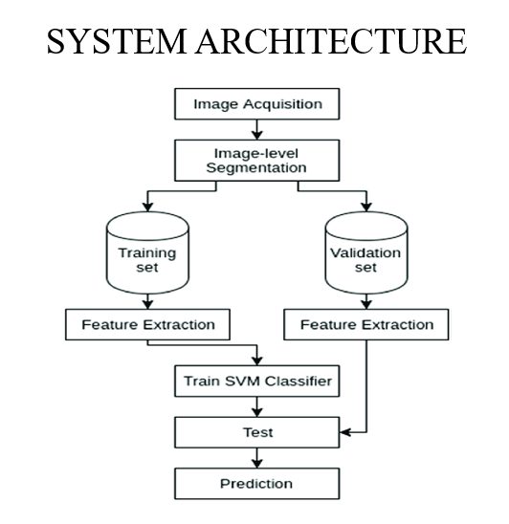

**Figure 5.1.1 System Architecture**

**5.2 UML DIAGRAMS**

**5.2.1 USECASE DIAGRAM**

Use case diagrams are behavior diagrams used to describe a set of actions (use cases) that some systems or systems (subject) should or can perform in collaboration with one or more external users(actor) of the system (actor). Initially a software application in MATLAB is created for the user(actor). The user(actor) submits their photographs of the disease in the Browse image segment (Use Case). The uploaded images are pre-processed (Use Case) and segmentation (Use Case) takes place. The Outputs of the segmentation are compared with the Pre-trained images in the database. After comparison the images are classified, by using the help of classification algorithm (Use Case). The application effectively finds out the type of skin disease the user(actor) is having. These helps the user(actor) to find out their problems in their skin without consulting a dermatologist.

Admin

User

System

**Figure.5.2.1.1 Use Case Diagram**

**5.2.2 CLASS DIAGRAM**

In this class diagram, initially a software application in MATLAB is created for the user. The user submits their photographs of the disease in the Browse image segment. The uploaded images are pre-processed and segmentation takes place. The Outputs of the segmentation are compared with the Pre-trained images in the database. After comparison the images are classified, by using the help of classification algorithm. The application effectively finds out the type of skin disease the user is having. These helps the user to find out their problems in their skin without consulting a dermatologist.

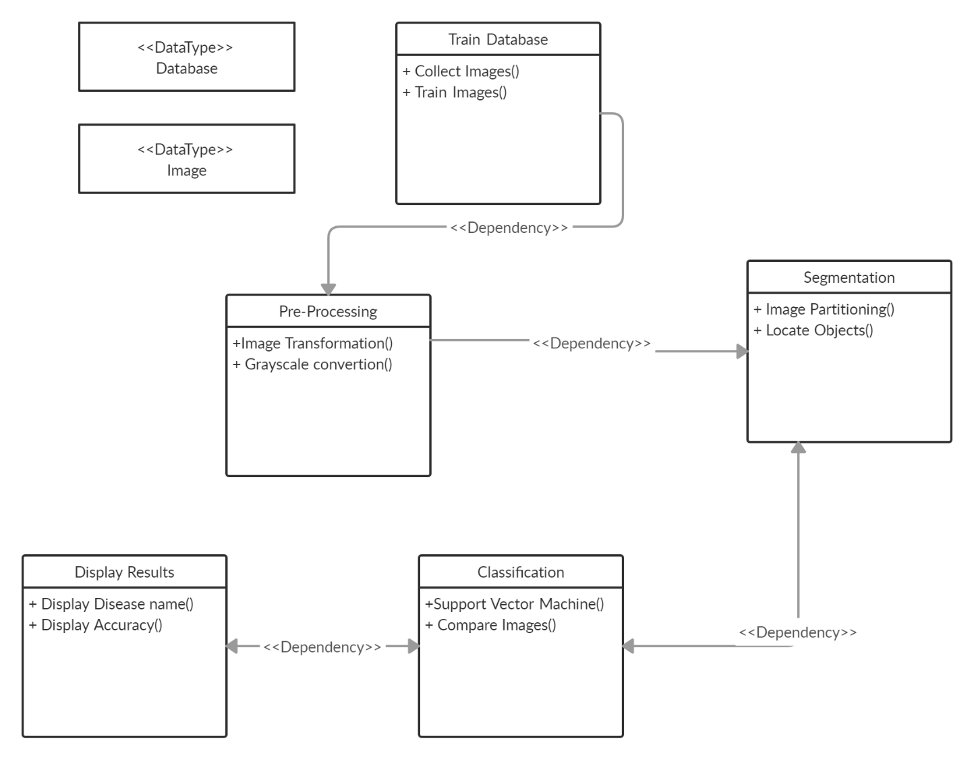

<<Datatype>> Tweets

Tweets Submission

Convey problems():Tweets Convey needs():Tweets Submit tweets():Tweets

Tweets Submission

Convey problems():Tweets Convey needs():Tweets Submit tweets():Tweets

**Figure.5.2.2.1 Class Diagram**

**5.2.3 SEQUENTIAL DIAGRAM**

UML Sequence Diagrams are interaction diagrams that detail how operations are carried out. They capture the interaction between objects in the context of a collaboration. Sequence Diagrams are time focus and they show the order of the interaction visually by using the vertical axis of the diagram to represent time what messages are sent. The sequence is as follows. initially a software application in MATLAB is created for the user. The user submits their photographs of the disease in the Browse image segment. The uploaded images are pre-processed and segmentation takes place. The Outputs of the segmentation are compared with the Pre-trained images in the database. After comparison the images are classified, by using the help of classification algorithm. The application effectively finds out the type of skin disease the user is having. These helps the user to find out their problems in their skin without consulting a dermatologist.

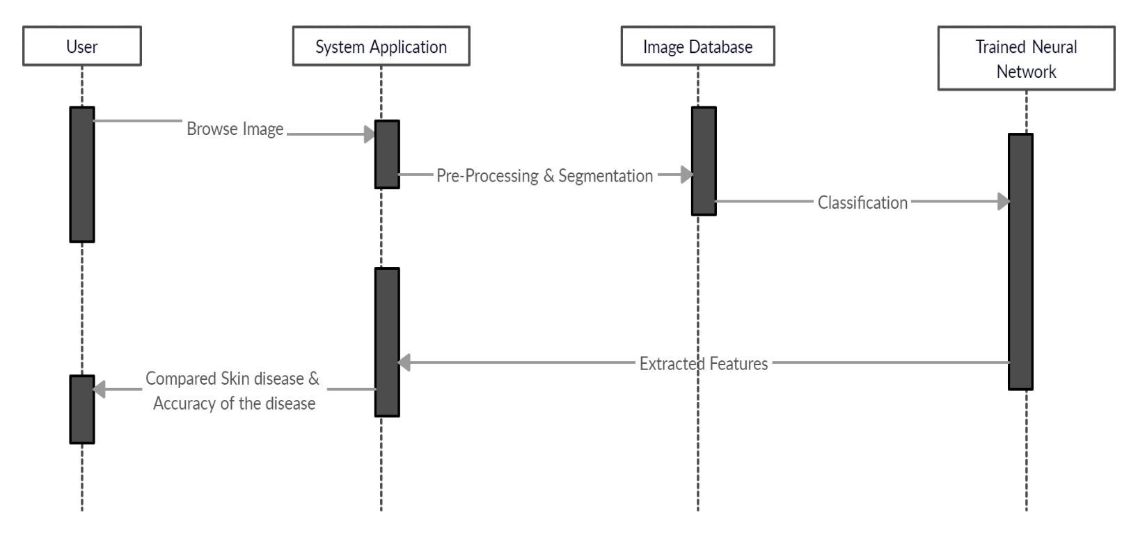

**Figure.5.2.3.1 Sequential Diagram**

**5.2.4 ACTIVITY DIAGRAM:**

Activity diagrams are the graphical representations of the work flows of the stepwise activities and actions with support for choice, iteration and Concurrency. An activity diagram shows the overall flow of control. The flow of the project is that the user has to upload the image. The Images are compared with the database to check whether they are having disease. After classification the results are displayed with accuracy.

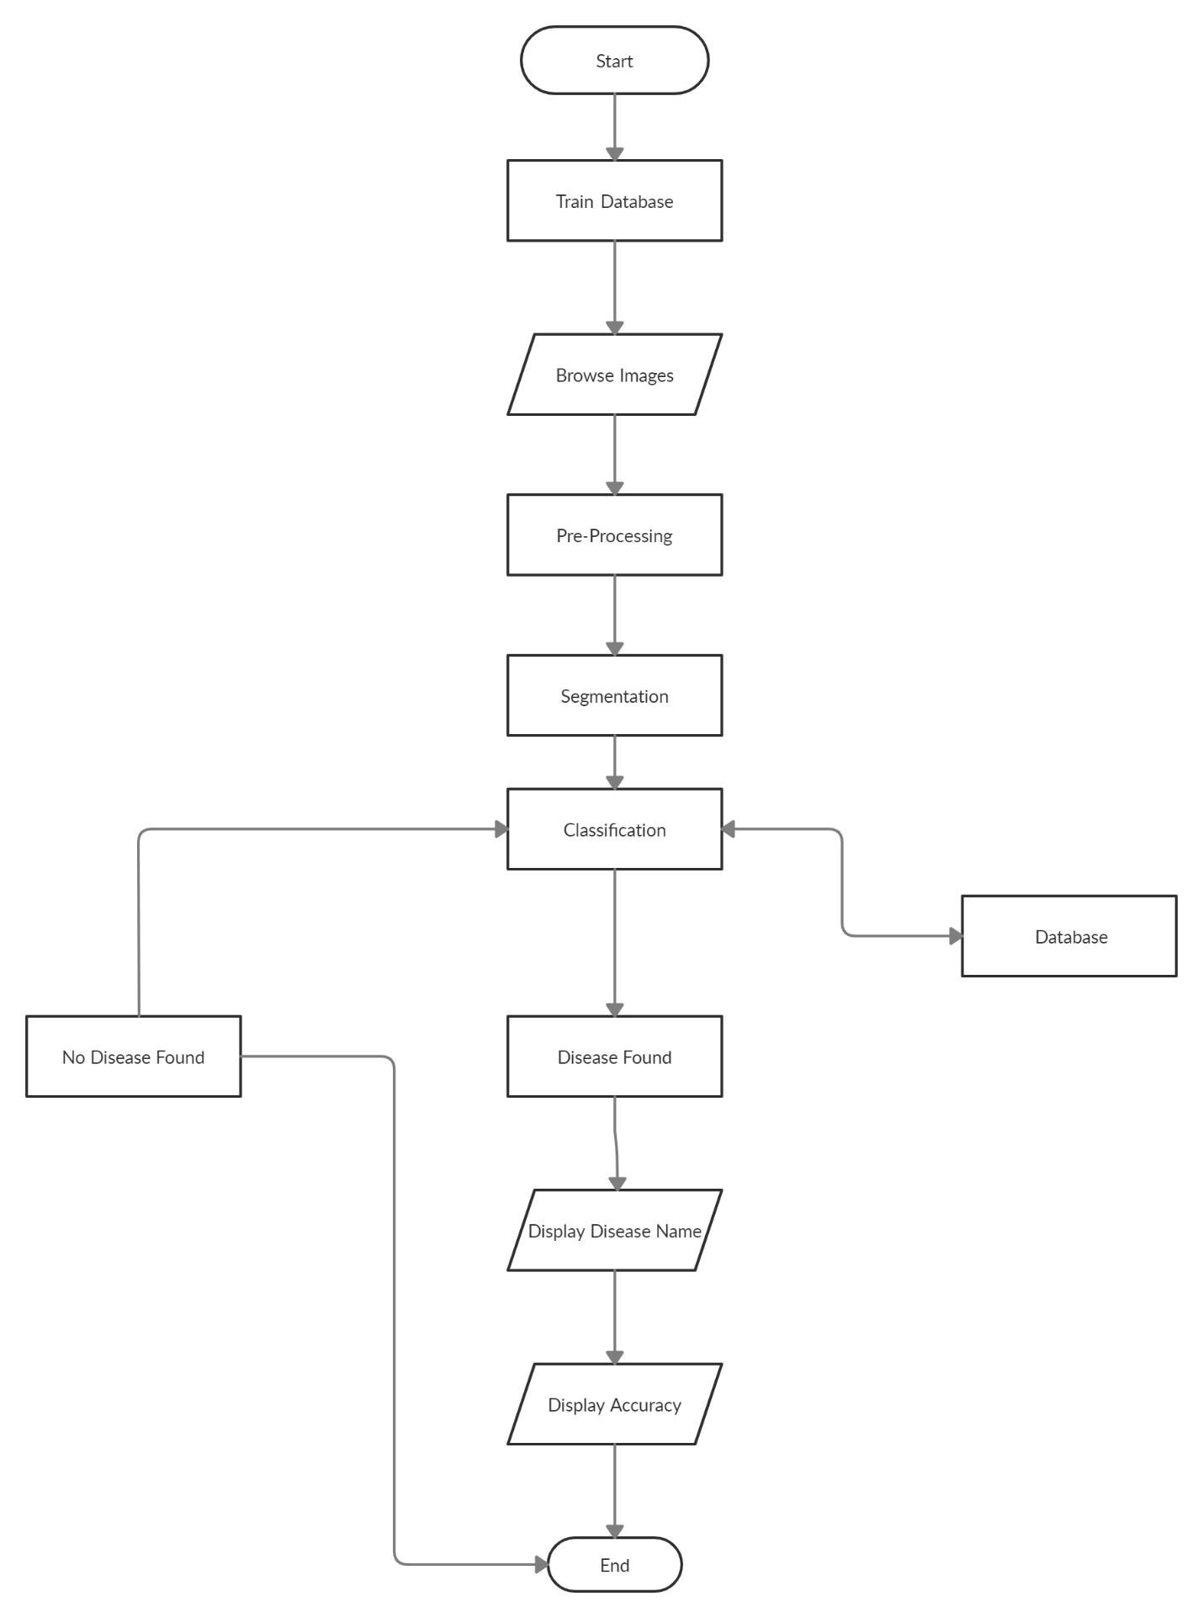

**Figure.5.2.4.1 Activity Diagram**

**5.2.5 COLLABORATION DIAGRAM:**

A collaboration diagram, also called a communication diagram or interaction

diagram, is an illustration of the relationships and interactions among software

objects in the Unified Modeling Language (UML). The various software objects

in the project includes: User(public), Matlab, Image Processing, Database(server).

The communication between those objects are shown as a sequence of steps.

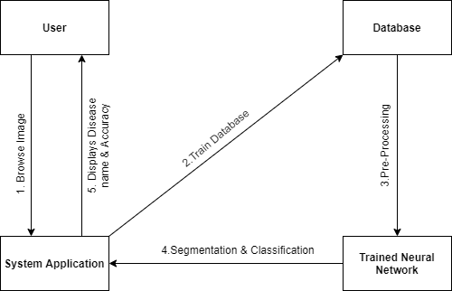

**Figure 5.2.5.1 Collaboration Diagram**

**CHAPTER 6**

**SYSTEM IMPLEMENTATION**

**6.1 MODULE DESCRIPTION**

The project is been executed to accomplish the results by four modules

namely**:**

* Train Database
* Pre-Processing
* Segmentation
* Classification

TRAIN DATABASE

PRE-PROCESSING

SEGMENTATION

CLASSIFICATION

**Figure 6.1.1 Module Description**

**6.1.1 TRAIN DATABASE**

For the training of our system, several images for each of our diseases were collected. Most of the images were downloaded from several websites and the database has been trained effectively. Algorithms learn from data. They find relationships, develop understanding, make decisions, and evaluate their confidence from the training data they’re given. And the better the training data is, the better the model performs. In fact, the quality and quantity of your training data has as much to do with the success of your data project as the algorithms themselves.

**6.1.2 PRE-PROCESSING**

Before using the images to train our model, series of preprocessing have been applied to our data to enhance the images also to increase our data for better generalization. All these processes were implemented using MATLAB image processing toolbox. In any Machine Learning process, Data Preprocessing is that step in which the data gets transformed, or Encoded, to bring it to such a state that now the machine can easily parse it.

**6.1.3 SEGMENTATION**

Image segmentation is performed to separate suspicious lesion from normal skin. This is implemented through MATLAB. Segmentation is the process of separating your data into distinct groups. This is a core activity in most business problems. A well‐defined segment is one in which the members of the segment are similar to each other and also are different from members of other segments. There are a number of ways to create segments but the most common is to use a clustering technique performed by a computer algorithm and then apply domain expertise.

**6.1.4 CLASSIFICATION**

This task is to load a pre-trained model and use it to classify the input data into a suitable class of skin diseases, this function is the main function of the application. Classification is a process of categorizing a given set of data into classes, It can be performed on both structured or unstructured data. The process starts with predicting the class of given data points. The classes are often referred to as target, label or categories. The classification predictive modelling is the task of approximating the mapping function from input variables to discrete output variables. The main goal is to identify which class/category the new data will fall into. Heart disease detection can be identified as a classification problem, this is a binary classification since there can be only two classes i.e. has heart disease or does not have heart disease. The classifier, in this case, needs training data to understand how the given input variables are related to the class. And once the classifier is trained accurately, it can be used to detect whether heart disease is there or not for a particular patient. Since classification is a type of supervised learn In machine learning, classification is a supervised learning concept which basically categorizes a set of data into classes. The most common classification problems are – speech recognition, face detection, handwriting recognition, document classification, etc. It can be either a binary classification problem or a multi-class problem too. There are a bunch of machine learning algorithms for classification in machine learning.

**CHAPTER 7**

**SYSTEM FEATURES**

**7.1 SYSTEM FEATURE 1**

Skin diseases are hazardous and often contagious, especially melanoma, eczema, and impetigo. These skin diseases can be cured if detected early. The fundamental problem with it is, only an expert dermatologist is able to detect and classify such disease. Sometimes, the doctors also fail to correctly classify the disease and hence provide inappropriate medications to the patient. Our system proposes a skin disease detection method based on Image Processing and Machine Learning Techniques. The patient needs to provide the image of the infected area and it is given as an input to the application. Initially, images were preprocessed to remove noise and irrelevant background by filtering and transformation. The method of grey-level co-occurrence matrix (GLCM) was introduced to segment images of disease. Texture and color features of different disease images could be obtained accurately. Initially a software application in MATLAB is created for the user. The user submits their photographs of the disease in the Browse image segment. The uploaded images are pre-processed and segmentation takes place. The Outputs of the segmentation are compared with the Pre-trained images in the database. After comparison the images are classified, by using the help of classification algorithm. The application effectively finds out the type of skin disease the user is having. These helps the user to find out their problems in their skin without consulting a dermatologist. Utilized computer aided diagnosis for the purpose of segmentation of the skin lesions of images obtained from dermoscopy. The methodology utilized for this was thresholding it automatically, using K- means, shifting by mean, growth regionally and Gradient Vector Flow (GVF).

**7.2 SYSTEM FEATURE 2**

# Before using the images to train our model, series of reprocessing have been applied to our data to enhance the images also to increase our data for better generalization. All these processes were implemented using MATLAB image processing toolbox. This task is to load a pre-trained model and use it to classify the input data into a suitable class of skin diseases, this function is the main function of the application. Image segmentation is performed to separate suspicious lesion from normal skin. This is implemented through MATLAB. This task is to load a pre-trained model and use it to classify the input data into a suitable class of skin diseases, this function is the main function of the application.

**CHAPTER 8**

**NON – FUNCTIONAL REQUIREMENT**

**8.1 PERFORMANCE**

Performance is a characteristic feature of an application which determines the use of the application over number of users. The performance results of the project for the is shown below:

**Table 1. Performance Analysis**

|  |  |  |
| --- | --- | --- |
| **Module Executed** | **Computation Time** | **Memory Consumption** |
| Train database | 10 seconds | 10.5 MB |
| Classification | 15 seconds | 15.4 MB |

**8.2 SAFETY**

A safety goal is a quality goal stating the importance of achieving a desired target regarding some safety factor such as “a system must not harm its users”. The project does not harm its users physically. Also, the project aims at providing the safety measures as they solve the problem of the public and the necessary actions are undertaken.

**8.3 SECURITY**

The privacy of the application is found to be more secure. Since, the data that is been communicated between the systems is through the cloud database that is been accessed only by the organization. Thus, the datasets and application code is handled only the organization provides security to the application.

**8.4 SOFTWARE QUALITY**

**8.4.1 RELIABILITY**

Reliability is considered to be important aspects to design into any system. A reliable product is totally free of technical errors and the project is found to be reliable of 75 percentage that it does not lead to any failures unless the input exceeds the capacity mentioned. Although, when required capacity is improved then application is found to be more reliable.

**8.4.2 USABILITY**

Usability is the degree to which a software can be used by specified consumers to achieve quantified objectives with effectiveness, efficiency, and satisfaction in a quantified context of use. The project interface is designed in more simple and understandable way that provides ease use of the application to achieve the defined objectives faster.

**8.4.3 PORTABILITY**

Portability is important characteristic in the current scenario of the environment as users requires an easy access over anywhere and anytime. The project is portability supportable since communications between the public and the organization is through a cloud database, thus can monitor and take appropriate actions are taken quickly.

**8.4.4 MAINTAINABILITY**

Maintenance of an application plays a vital role when there are some changes in the inputs provided or even a technological updation. The maintainability of the project is much easier since MATLAB is used. Also, the main change over the project involves creating dynamic application and this is done by changing a few pieces of code written.

**CHAPTER 9**

**CONCLUSION**

Difficulties in the diagnosing skin diseases arise because of the spreading of the skin diseases all over the world, which make it a challenge to the dermatologist to recognize the different skin diseases easily, a computer aided system is proposed to resolve these difficulties, so a machine learning model based on bag of features algorithm is designed which use SVM as a classifier for feature extraction. The core model is developed using MATLAB and the interface is developed using on windows OS.

The developed system performs the required work with accuracy 94% within the dataset and 85% with the external data, and the integrated system is working properly, although the system works fine there are some points that bound the performance of the system such as that, there is a single processor of the system that is used to classify the images, which will reduce the performance of the whole system with the increase of the requests from multiple users.

**APPENDIX –I (SCREENSHOTS)**

# 

# 

# A.1.1 TRAIN DATABASE

# 

# A.1.2 PRE-PROCESSING

# A.1.3 SEGMENTATION

# 

# A.1.4 CLASSIFICATION

**APPENDIX II(SAMPLE CODING)**

function varargout = skin_disease_detection(varargin)

gui_Singleton = 1;

gui_State = struct('gui_Name', mfilename, ...

'gui_Singleton', gui_Singleton, ...

'gui_OpeningFcn', @skin_disease_detection_OpeningFcn, ...

'gui_OutputFcn', @skin_disease_detection_OutputFcn, ...

'gui_LayoutFcn', [] , ...

'gui_Callback', []);

if nargin && ischar(varargin{1})

gui_State.gui_Callback = str2func(varargin{1});

end

if nargout

[varargout{1:nargout}] = gui_mainfcn(gui_State, varargin{:});

else

gui_mainfcn(gui_State, varargin{:});

end

function skin_disease_detection_OpeningFcn(hObject, eventdata, handles, varargin)

handles.output = hObject;

axes(handles.axes1); axis off

axes(handles.axes2); axis off

axes(handles.axes3); axis off

set(handles.edit1,'String','---');

set(handles.edit7,'String','---');

guidata(hObject, handles);

function varargout = skin_disease_detection_OutputFcn(hObject, eventdata, handles)

varargout{1} = handles.output;

function pushbutton1_Callback(hObject, eventdata, handles)

global im;global a;

[fname,path]=uigetfile('*.*','Browse Ear');

if fname~=0

img=imread([path,fname]);

axes(handles.axes1); imshow(img);title('Input Image');

im=img;a=im;

tts('Input Image is selected');

else

warndlg('Please Select the necessary Image File');

tts('Please Select the necessary Image File');

end

function pushbutton2_Callback(hObject, eventdata, handles)

global im;global I;global K;global BW1;global B;

global f;global C;global S;global se;global close;global gray;global wlab;global Skin;

im = im2double(im);

lab = rgb2lab(im);

f = 0;

wlab = reshape(bsxfun(@times,cat(3,1-f,f/2,f/2),lab),[],3);

[C,S] = pca(wlab);

S = reshape(S,size(lab));

S = S(:,:,1);

Skin=86;

gray = (S-min(S(:)))./(max(S(:))-min(S(:)));

se = strel('disk',1);

close = imclose(gray,se);

K= imcomplement(close)

[cA,cH,cV,cD] = dwt2(K,'bior1.1');

thresh1 = multithresh(cA);

thresh2 = multithresh(cH);

thresh3 = multithresh(cV);

thresh4 = multithresh(cD);

level = (thresh1 + thresh2 + thresh3 + thresh4)/2;

X = idwt2(cA,cH,cV,cD,'bior1.1')

BW=imquantize(X,level);

BW1 = edge(edge(BW,'canny'), 'canny');

axes(handles.axes2); imshow(K);title('Preprocessing Image');

tts('Preprocess is done');

function pushbutton3_Callback(hObject, eventdata, handles)

global im;global B;global BW1;global gk;global Skin;

tts('Segmentation is Started....');

BW3 = imclearborder(BW1);

CC = bwconncomp(BW3);

S = regionprops(CC, 'Area');

L = labelmatrix(CC);

BW4 = ismember(L, find([S.Area] >= 100));

BW5 = imfill(BW4,'holes');

[B,L,N] = bwboundaries(BW5);

axes(handles.axes3); imshow(im);title('Segmented Image');hold on;

for k=1:length(B),

boundary = B{k};

plot(boundary(:,2),...

boundary(:,1),'g','LineWidth',2);

end

gk=8;

function pushbutton4_Callback(hObject, eventdata, handles)

msgbox('Ready to Create the database....');

tts('Ready to Create the database....');

pause(1)

msgbox('Process Start....');

tts('Process Start....');

pause(1)

s=0;

for i=1:6

j=num2str(i);

imgname=strcat(j,'.jpg');

b=imread(imgname);

b=imresize(b,[250 250]);

save database b

end

msgbox('Database Created....');

tts('Database Created....');

function edit1_Callback(hObject, eventdata, handles)

function edit1_CreateFcn(hObject, eventdata, handles)

if ispc && isequal(get(hObject,'BackgroundColor'), get(0,'defaultUicontrolBackgroundColor'))

set(hObject,'BackgroundColor','white');

end

function pushbutton5_Callback(hObject, eventdata, handles)

close skin_disease_detection

function pushbutton6_Callback(hObject, eventdata, handles)

tts('Resetting Application....');

axes(handles.axes1); cla(handles.axes1); title(''); axis off

axes(handles.axes2); cla(handles.axes2); title(''); axis off

axes(handles.axes3); cla(handles.axes3); title(''); axis off

set(handles.edit1,'String','**');

set(handles.edit7,'String','**');

clc;

clear all;

function pushbutton7_Callback(hObject, eventdata, handles)

global I;global a;global gk;global Skin;

tts('Classification is Started....');

meann = mean2(a);

y = round(meann);

set(handles.edit1,'String',y);

if (y==163 && gk==8)

set(handles.edit1,'String','basal cell carcinoma ');

elseif (y==161 && gk==8)

set(handles.edit1,'String','squamous cell carcinoma');

elseif (y==165 && gk==8)

set(handles.edit1,'String','BASAL CANCER ');

elseif (y==137 && gk==8)

set(handles.edit1,'String','melanoma ');

y=y+20;

elseif (y==181 && gk==8)

set(handles.edit1,'String','melanoma ');

y=y-30;

elseif (y==201 && gk==8)

set(handles.edit1,'String','Normal Issue ');

y=y-30;

else

tts('Contact Admin....');

end

Acc=y/100;

Accuracy=Skin+Acc;

set(handles.edit7,'String',Accuracy);

function edit2_Callback(hObject, eventdata, handles)

function edit2_CreateFcn(hObject, eventdata, handles)

if ispc && isequal(get(hObject,'BackgroundColor'), get(0,'defaultUicontrolBackgroundColor'))

set(hObject,'BackgroundColor','white');

end

function edit3_Callback(hObject, eventdata, handles)

function edit3_CreateFcn(hObject, eventdata, handles)

if ispc && isequal(get(hObject,'BackgroundColor'), get(0,'defaultUicontrolBackgroundColor'))

set(hObject,'BackgroundColor','white');

end

function edit4_Callback(hObject, eventdata, handles)

function edit4_CreateFcn(hObject, eventdata, handles)

if ispc && isequal(get(hObject,'BackgroundColor'), get(0,'defaultUicontrolBackgroundColor'))

set(hObject,'BackgroundColor','white');

end

function edit5_Callback(hObject, eventdata, handles)

function edit5_CreateFcn(hObject, eventdata, handles)

if ispc && isequal(get(hObject,'BackgroundColor'), get(0,'defaultUicontrolBackgroundColor'))

set(hObject,'BackgroundColor','white');

end

function edit7_Callback(hObject, eventdata, handles)

function edit7_CreateFcn(hObject, eventdata, handles)

if ispc && isequal(get(hObject,'BackgroundColor'), get(0,'defaultUicontrolBackgroundColor'))

set(hObject,'BackgroundColor','white');

end

# REFERENCES

1. Young, B.; Wheater's Functional Histology: A and Colour Atlas (with student consult online access), Functional Histology Wheater's, (2013) ed. 6e.
2. Norton, M.E.; Rose, N.C.; and Benn, P.; Noninvasive prenatal testing for fetal aneuploidy: clinical assessment and a plea for restraint. Obstetrics & Gynecology, 121(4), (2013)**,** 847-850.
3. Feng, J.; et al., Metabolites Studies of Secondary Melanoma on C57BL/6J Mouse Liver Using 1H NMR Metabolomics. 3(4), (2013), 1011-1035.
4. Randy Gordon,;‖ Skin Cancer: An Overview of Epidemiology and Risk Factors‖, Seminars in Oncology Nursing, 29(3), (2013), 160-169.
5. Mrs S.Kalaiarasi,Harsh Kumar,Sourav Patra:Dermatological Disease Detection using Image Processing and Neural Network, 2018
6. Dr S.Mohan Kumar,Shwetha,Shreya Ranja,Sri Lakshmi Chundru, et.al:Surveys on detection of Melanoma through Image Processing techniques,2018
7. Megha D. Tijare, Dr V.t Gaikwad: Texture based feature extraction for skin disease detection,2016
8. Desai Bijal Pareshbhai,Prof. Bhatt Bhumika: Vitiligo detection techniques,2017